Authors:

Abhilasha Kumari

Ashok Kuruvilla Eapen

Pranav Agarwal

Rohit Pattnaik

Bayesian Modeling Workshop on US Vehicle Crash Data

Contents

**Aim** 3

**Data Pre-processing** 3

**Data Cleansing Approach** 3

• Deletion 3

• Imputation 3

**Data Binning** 4

**Binning Method Used** 5

• Uniform Width Binning 5

• Uniform Count Binning 5

**Preparing Test and Validation data** 6

**Inference** 7

**Model Testing** 8

**Validation Results** 8

**Model Improvement** 10

**Naïve Bayes Model Vs Tree Augmented Naive Bayes Model Comparison** 12

**Conclusion** 12

# **Aim**

* To Build a Naïve Bayes network and Tree Augmented Naïve Bayes network to predict the likely injury level for vehicle occupants and then compare the results
* To Interact with GeNie Bayesian Network and understand the factors impacting vehicle safety

# **Data Pre-processing**

A Total of 20247 observations were considered for building the model. The rows with missing data across the fields were removed and sanitized. The data was assured to have uniqueness, accuracy, consistency and integrity by performing the standard data cleansing methods.

# **Data Cleansing Approach**

## **Deletion**

The target Prediction variable (OA-MAIS) contained 1044 missing values out of 20247 records present. List-wise deletion method was used to delete the 1044 missing rows of data since it comprised of only 5% of the total data set.

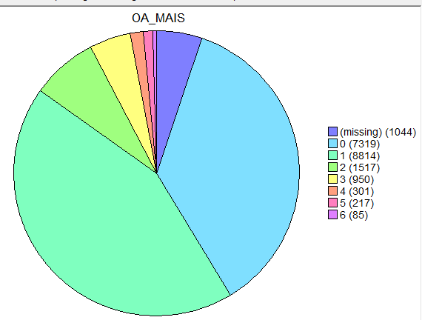

***Fig 1.1:*** *Missing data in Target Variable*

## **Imputation**

* Mean Imputation was performed to fill in the missing data for continuous data field columns
* Mode Imputation was performed to fill in the missing data for nominal and ordinal data field columns
* Maximum Likelihood imputation was done to fill in the missing data for categorical data field   
  columns

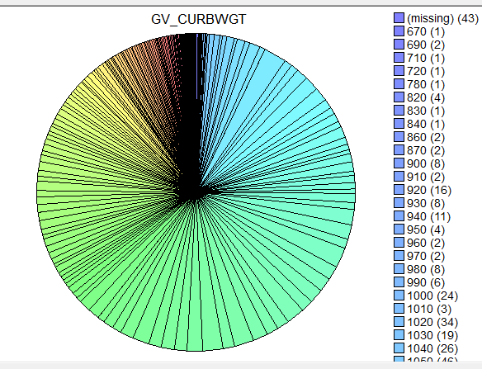 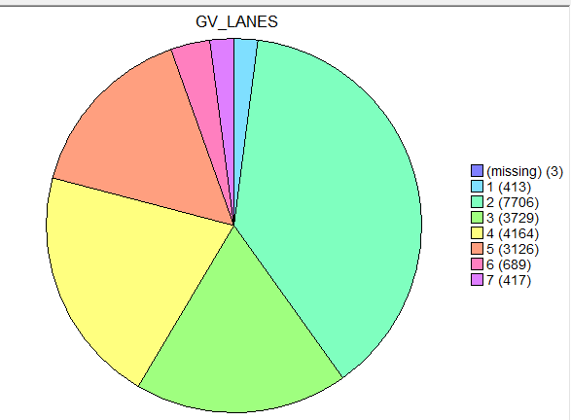 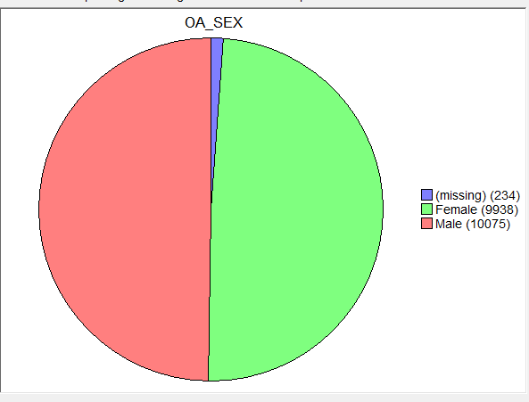

***Fig1.2****:Left to Right( continuos data , ordinal data, categorical) data with missing values*

* After Imputation following data distribution was observed:

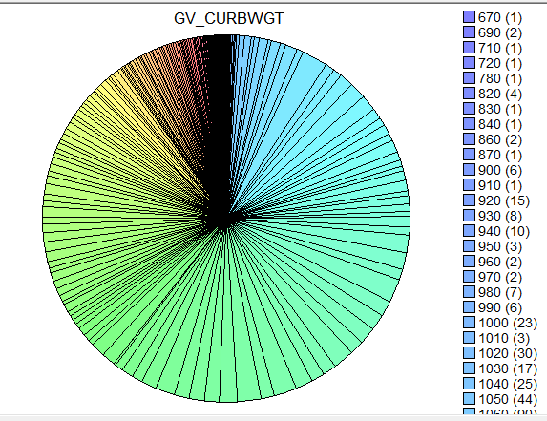 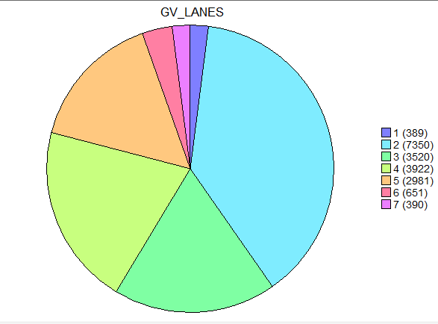 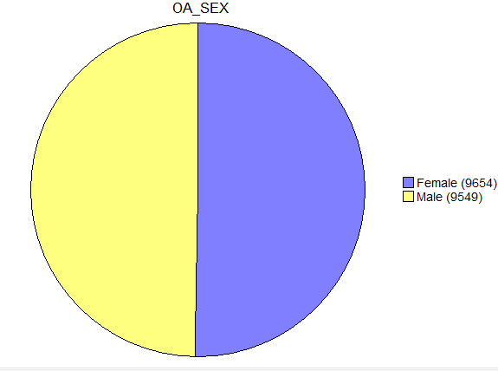

***Fig1.3****:Left to Right( continuos data , ordinal data, categorical data) after data Imputation*.

# **Data Binning**

We utilized the knowledge about cars in the best possible way to discretize the data set using appropriate binning methods that helped us to get the best predictive model performance

* The US crash data set contained 21 variables out of which 14 variables were continuous variables and the remaining were categorical.
* Data Binning technique (It is a way to group more or lesser number of continuous values into a smaller no of bins) was used for pre-processing the continuous data.
* By the use of unsupervised binning methods and some subject knowledge about the cars in hand, numerical variables were converted into categorical variables.
* In addition to this outliers were identified and invalid or missing values were removed. Thus, improving accuracy of the model by reducing noise or non-linearity.

# 

# **Binning Method Used**

## **Uniform Width Binning**

## **Uniform Count Binning**

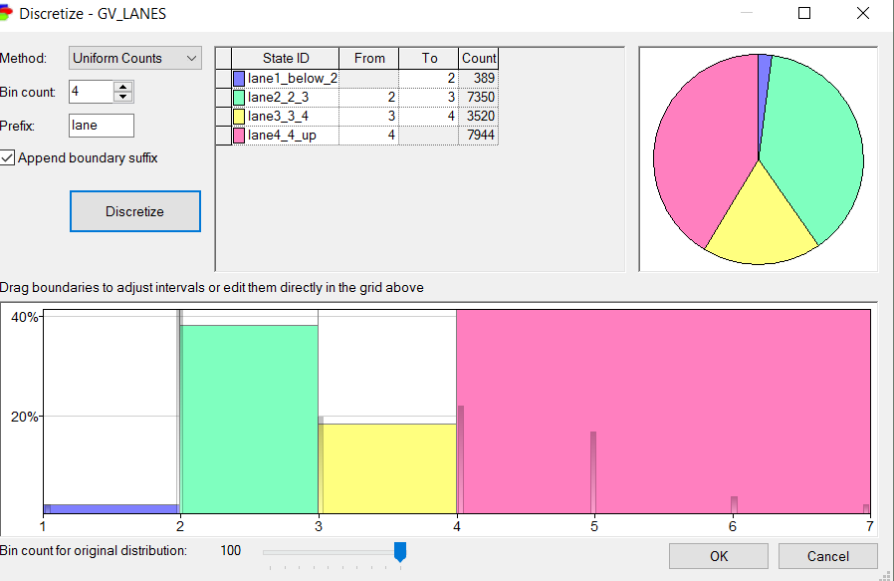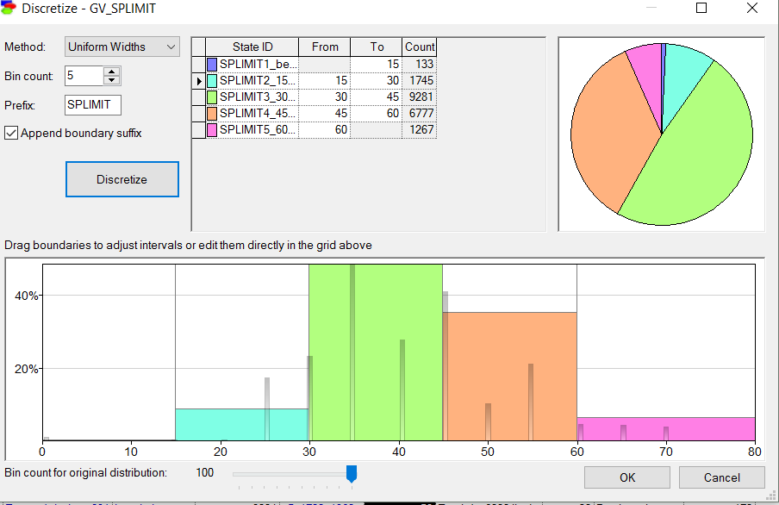

***Fig 2.1****: Illustration of uniform count method and uniform width method*

In the above figure, road_lanes has been divided using uniform count binning method and car_speed_limit has been divided using uniform width method.

Final dataset after applying all data cleaning techniques:

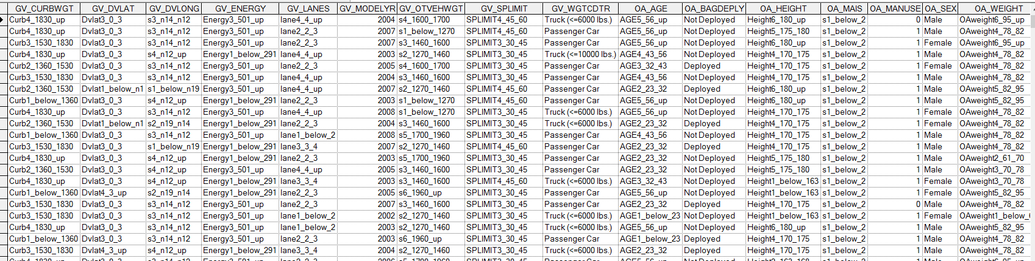

***Fig 2.2:*** *Final data set for model building*

# **Preparing Test and Validation data**

The data was split into Test and Train data in the ratio of 70:30 so as to project proper representation of the entire occupants.

Since the data set was of moderate size we used K fold cross validation method for separating the test and train data.

**Model Building**

After having sanitized the data set for prediction of “Injury levels” of vehicle occupants, a model was built using Naïve Bayes prediction.

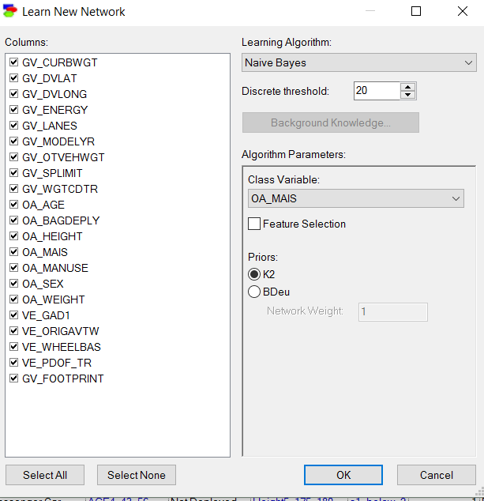

***Fig 3.1:***  *selection of Naïve Bayes as prediction model in GeNie Software*

Naïve Bayes Model was built after setting the trigger as male for the variable OA_SEX.

The network had a probability of 84% for “minor or no injuries”.

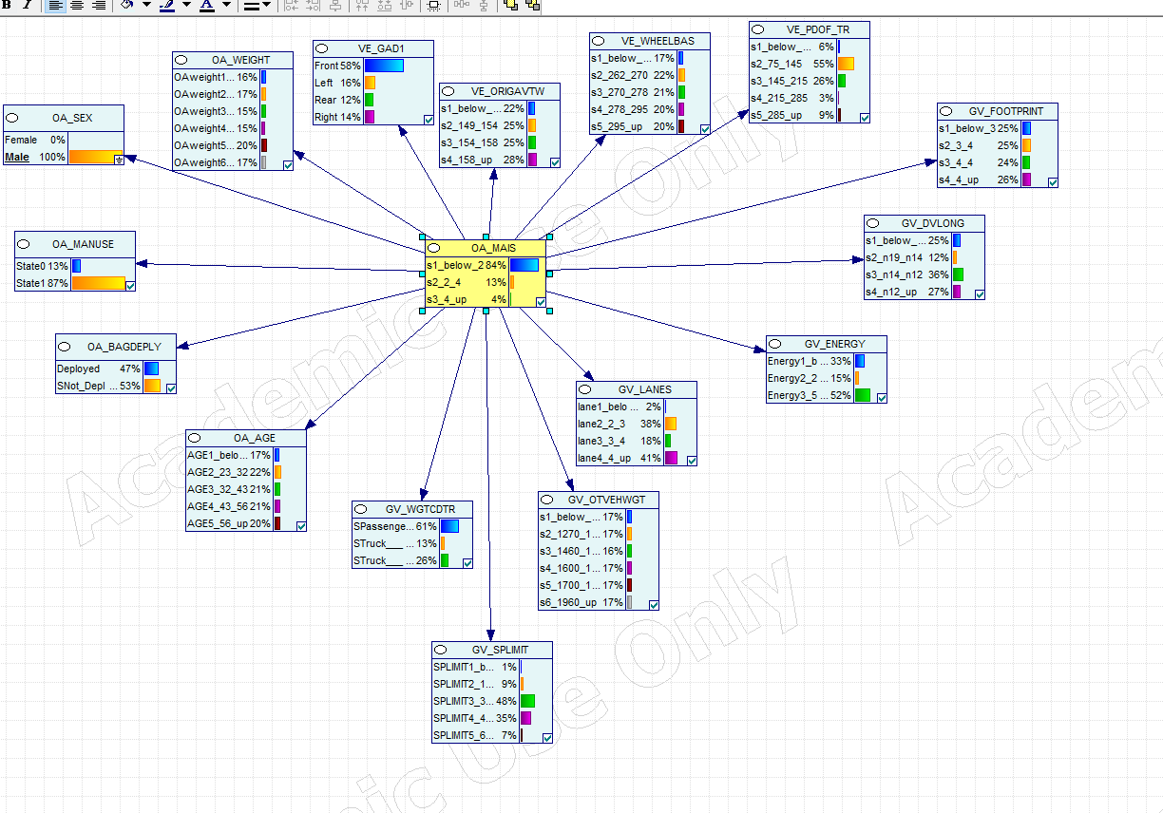

***Fig3.2:*** *Detailed Naïve Bayes network diagram for predicting injury level of vehicle occupants.*

# **Inference**

The following inferences can be made from the model:

* When the trigger for the category “sex” was set as “male” ~ 84% of the vehicle occupants didn’t suffer any injury or sustained minor /moderate injuries, 13% suffered serious or critical injuries and the remaining could not survive.
* Metrics also shows that 58% of vehicle collisions happen in the vehicle frontal region.
* It also shows that 87% of occupants didn’t use seat belts.

# **Model Testing**

We have used K fold cross validation method to validate our model. We selected fold count of 5 and seed count of 250 for our validation. During this validation test, data set was divided into 5 subsets, and the process was repeated 5 times. Each time, one of the 5 subsets was used as the test set and the other 4 subsets were put together to form a training set. Every data point gets to be in a test set exactly once, and gets to be in a training set 4 times. Then the average error across all 5 trials was computed.

The advantage of using this method is that it does not depend on how the data gets divided.

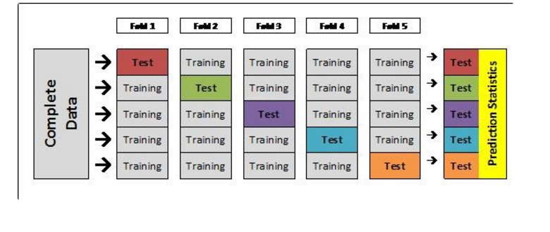

***Fig 4:*** *Schematic representation of 5-fold cross validation.*

# **Validation Results**

1. **Model Accuracy:**

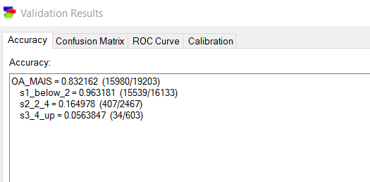

***Fig 5.1:*** *Accuracy of the model when trigger is set to male*

1. **Confusion Matrix**

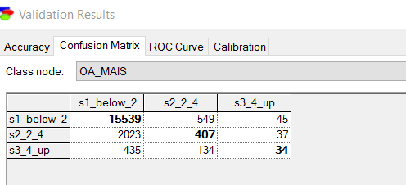

***Fig 5.2:*** *Confusion matrix derived after modelling*

1. **Accuracy**

The Accuracy of the model was found out to be **83.216%** out of which **99.6%** of “s1_below_2” class, **16.498%** of “s2_2_4” class ,and **5.638%** of class “s3_4_up “are captured by the model.

1. **ROC (Receiver operating characteristic) Curve and AUC**

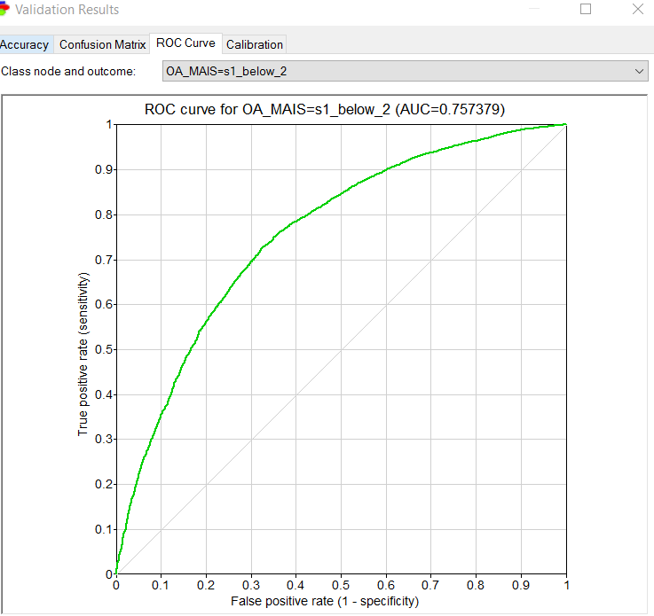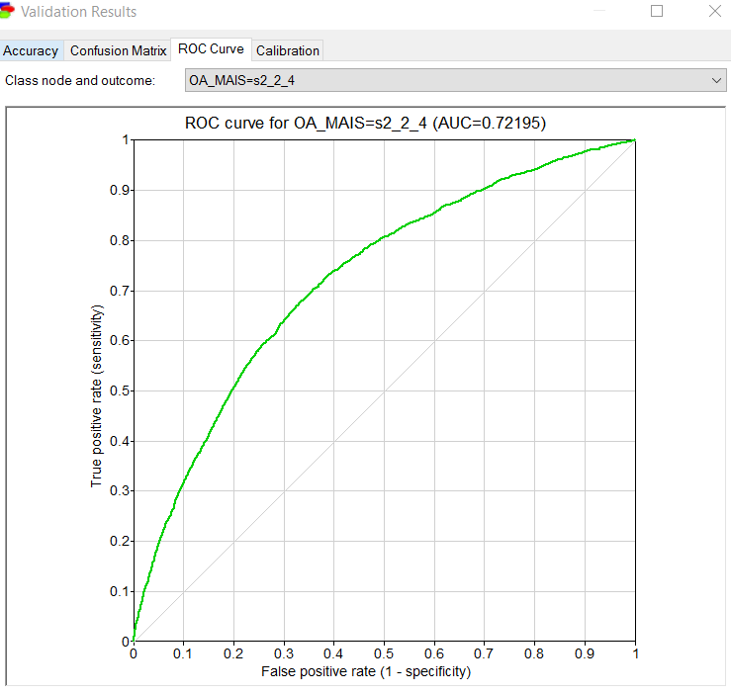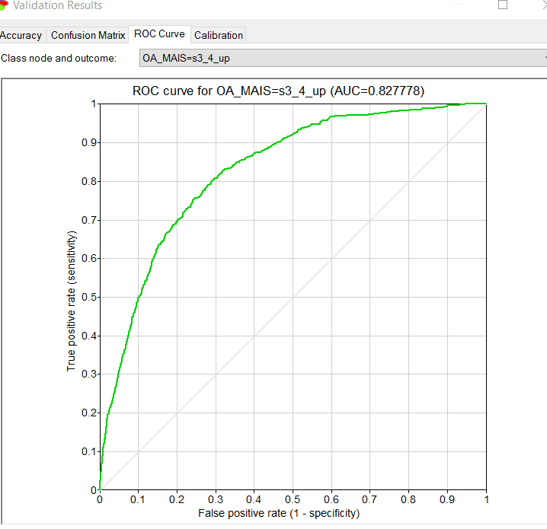

***Fig 6****: Area under**ROC Curve and AUC Curve*

The Area under the ROC Curve as shown in the figure above has:

* **“75.74% “**for class “s1_below_2”
* “**72.20%**” for class “s2_2_4”
* **“82.78%**”forclass“s3_4_up”

Hence, from the above observations it can be concluded that model is accurate.

# **Model Improvement**

The model was improved by removing the variables having weak correlation with the target variable using the correlation matrix and rebuilding the model again using Naïve Bayes Algorithm.

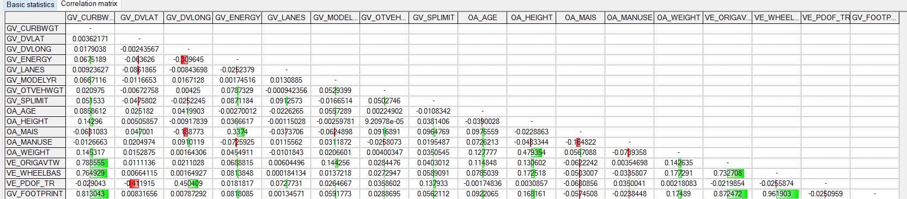

***Fig 7.1:*** *Correlation matrix showing the correlation between different variables.*

The new model gave us as an overall accuracy of **“84 .1%”** which suggests model predication improved by **1%.**

**New Accuracy and Confusion Matrix**

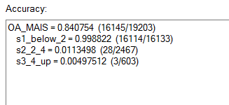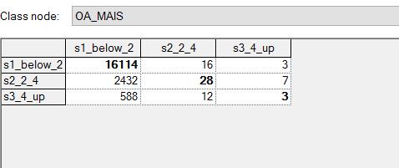

***Fig 7.2:*** *New Accuracy and Confusion Matrix.*

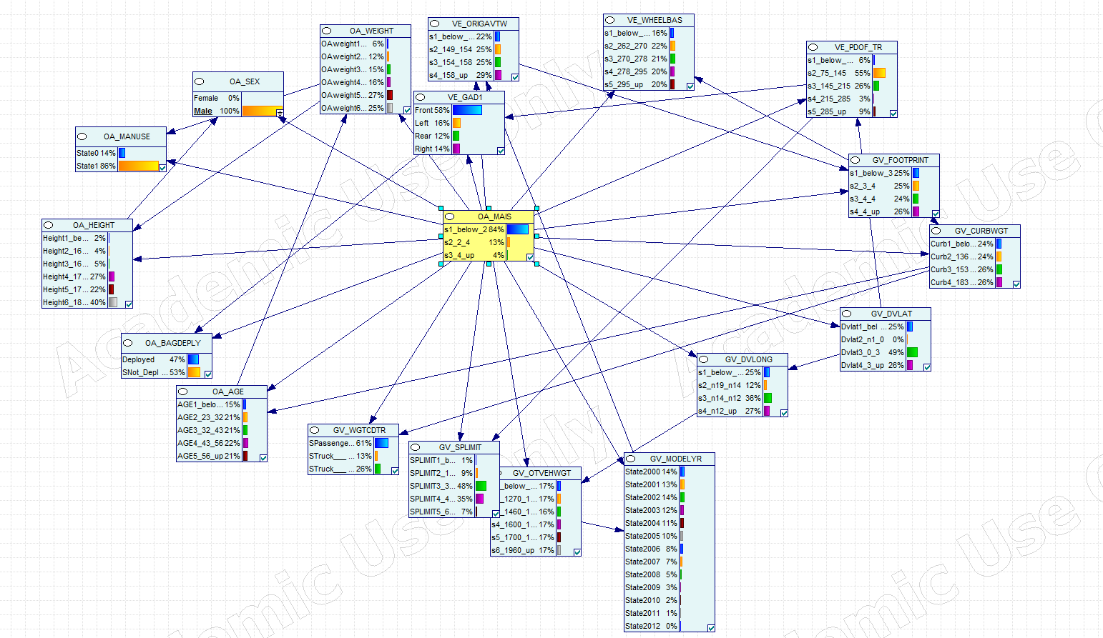

***Fig7.3:*** Tree Augmented Naïve Bayes Model for the same dataset

**Accuracy and Confusion Matrix of Tree Augmented Naïve Bayes Model**

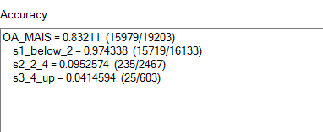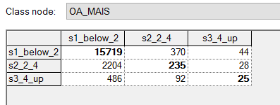

***Fig 7.3:*** *Accuracy and Confusion Matrix of Tree Augmented Naïve Bayes Model*

# 

# **Naïve Bayes Model Vs Tree Augmented Naive Bayes Model Comparison**

|  |  |  |  |  |  |  |  |
| --- | --- | --- | --- | --- | --- | --- | --- |
| Model | Accuracy | Error Rate | Sensitivity | Specificity | Precision | Recall | F |
| Naïve Bayes (A) | 83.216% | 16.784% | 86.34% | 5.6% | 96.318% | 86.34% | 91.05 |
| Naïve Bayes after removing weakly correlated variables (A1) | 84.075% | 15.925% | 99.88% | 4.9% | 97.88% | 84.21% | 90.53 |
| Tree Augmented Naïve Bayes (B) | 81.042% | 18.958% | 86.44% | 8.12% | 96.48% | 86.41% | 91.16 |
| Tree Augmented Naïve Bayes after removing weakly correlated variables (B1) | 84.107% | 15.893% | 84.962% | 7.13% | 99.145% | 84.96% | 91.50 |

# **Conclusion**

From the above table it can be concluded that among model **A**(Naïve Bayes)**, A1**(Naïve Bayes after removing weakly correlated variables)**, B**(Tree Augmented Naïve Bayes)and **B1**(Tree Augmented Naïve Bayes after removing weakly correlated variables) **B1 is the best model as the accuracy is 84.107% and precision is 99.145%.**